JUN-AIR Oil lubricated compressors Recommended Service Intervals

**Checking the pumping time (Compressors)**

The pumping time indicates the condition of the compressor provided there are no leaks in the system.

Test the compressor as follows.

* Empty the Air receiver of compressed air (the pressure gauge shows 0)
* Close the outlet on the air receiver and check drain cock is closed
* Start compressor and note how long it takes to achieve 8 bar/120 p.s.i. (See reference table below).

Pumping time Reference table for Oil lubricated series

|  |  |
| --- | --- |
| **Model 3** | |
| **3-1.5** | 1 min |
| **3-4.0** | 2 min 40sec |
|  |  |
| **Model 6** | |
| **6-4.** | 1 min |
| **6-15.** | 3 min 40 sec |
| **6-25.** | 6 min 5 sec |
| **12-25.** | 3 min 5 sec |
| **12-40.** | 4 min 35 sec |
| **12-50.** | 6 min 5 sec |
| **18-40.** | 3 min 5 sec |
| **18-50** | 4 min 5 sec |
| **36-150** | 4 min 45 sec |

2000 Hour basic Service

Intake air filters and non-return valves parts should be replaced every 2000 hours for maximum performance and protection of the motor. The intake filter should be changed more often when the motor is operating in extreme conditions with high levels of contaminants in the air. Non-return valve parts should be replaced every 2000 hours under normal operating conditions.

|  |  |  |
| --- | --- | --- |
| **Part number** | **Model** | |
| 5472010 | Basic M3 | |
| 5472014 | Basic M6 | |
| For models 12-18-24 & 36 use multiples of Basic M6 (5472014) | | |
| Oil lubricated compressor basic Service Procedure | | |
|
|
|
|
|
|

**Basic Service for M6/M3**

* Switch off compressor and isolate from mains supply and always wear safety glasses.
* Drain receiver of any moisture and compressor Air
* Before removing motor from receiver always discharge the capacitor (fig 1)
* **If at any time you are unsure please consult a qualified Engineer**
* Remove motor from receiver
* Remove lid from motor
* Remove delivery pipe cover and lift pipe (see fig 2).
* Disconnect internal electrical plug (Fig 3).
* Unhook springs x (3) old M6 from suspension lugs (Fig 4). New M6 are mounted on location pegs
* Remove motor from casing and remove top bearing for cleaning and inspection of any damage
* Dispose of used oil according to local environmental rules.
* Replace top bearing and torque accordingly (9 Nm) (Fig 5)
* Making sure motor casing is clean from any debris place motor back into casing ensuring electrical plug is connected correctly and mounted on suspension springs. (Fig 6). New gasket is supplied for delivery pipe. (4548000)
* Re-fill with new SJ-27F oil (5631000) to recommended level making sure motor is free to rotate. (Fig 7)
* Fit new rib cover 0-ring (6244000) and oil filler cap gasket (6235000) before sealing motor.
* Place motor back on receiver, reconnect electrically and fit new intake filter 5412000.

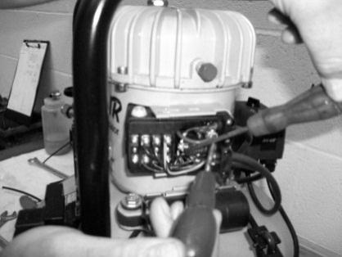 Fig 1 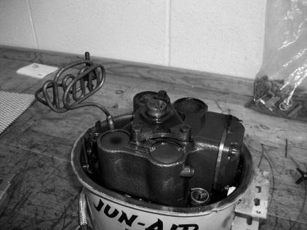 Fig 2 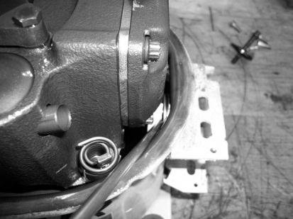 Fig 3

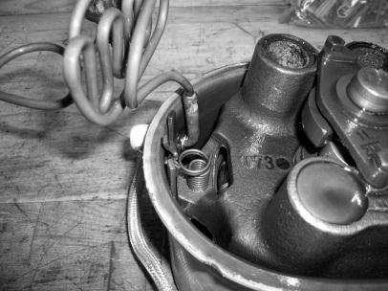 Fig 4 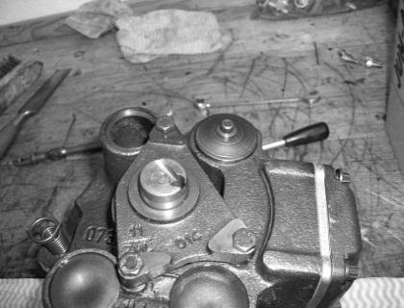 Fig 5 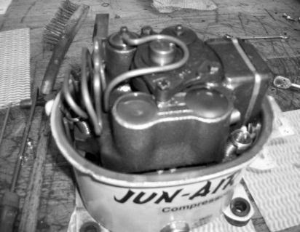 Fig 6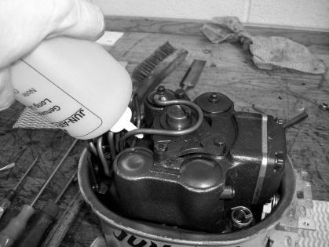 Fig 7

* Dismantle non-return valve(s) replace both 0-rings (6243000 & 6242500) and spring 5820001 (Fig 8)

Fig 8

* While compressor is building pressure check safety valve by operating pull ring (1) or by turning the screw (2) depending on the type of valve (Fig 9)

Fig 9